198. House Robber
You are a professional robber planning to rob houses along a street. Each house has a certain amount of money stashed, the only constraint stopping you from robbing each of them is that adjacent houses have security systems connected and it will automatically contact the police if two adjacent houses were broken into on the same night.
Given an integer array nums representing the amount of money of each house, return the maximum amount of money you can rob tonight without alerting the police.

Example 1:
Input: nums = [1,2,3,1]
Output: 4
Explanation: Rob house 1 (money = 1) and then rob house 3 (money = 3).
Total amount you can rob = 1 + 3 = 4.
Example 2:
Input: nums = [2,7,9,3,1]
Output: 12
Explanation: Rob house 1 (money = 2), rob house 3 (money = 9) and rob house 5 (money = 1).
Total amount you can rob = 2 + 9 + 1 = 12.

416. Partition Equal Subset Sum
Given an integer array nums, return true if you can partition the array into two subsets such that the sum of the elements in both subsets is equal or false otherwise.

Example 1:
Input: nums = [1,5,11,5]
Output: true
Explanation: The array can be partitioned as [1, 5, 5] and [11].
Example 2:
Input: nums = [1,2,3,5]
Output: false
Explanation: The array cannot be partitioned into equal sum subsets.
329. Longest Increasing Path in a Matrix
Given an m x n integers matrix, return the length of the longest increasing path in matrix.
From each cell, you can either move in four directions: left, right, up, or down. You may not move diagonally or move outside the boundary (i.e., wrap-around is not allowed).

Example 1:
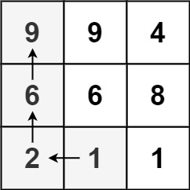
Input: matrix = [[9,9,4],[6,6,8],[2,1,1]]
Output: 4
Explanation: The longest increasing path is [1, 2, 6, 9].
Example 2:
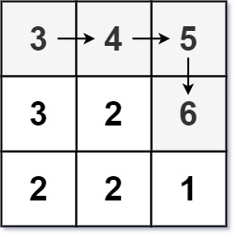
Input: matrix = [[3,4,5],[3,2,6],[2,2,1]]
Output: 4
Explanation: The longest increasing path is [3, 4, 5, 6]. Moving diagonally is not allowed.

